ARM
By Rathod Raja V.

1. Explain ARM architecture?
Ans:
1. ARM statnd for Advanced RISC Machine.
2. It supports RISC architecture.
3. It use only two control signal Memory Read and Memory Write.
4. Support Pipeline.
5. In single clock, execution of multiple instruction.
6. Same address for I/O and Memory.
7. Emphasis on Software
8. Fast performance.
9. Low power consumption.
10. Support Load and store Instruction set.
11. Use for specific purpose application.
12. Complexity in compiler.
13. ARM having total 4 profile
A. Classic Processor
B. Cortex-M Serries
C. Cortex-R serries
D. Cortes-A serries
14. Within the device the componant are connected together using AMBA bus.
15. AMBA specifies two buses:
A. High perforamance system bus AXI: For connecting peripherals
B. Low power bus APB : For memory Interface

16. ARM having total 37 register set.

2. Explain differences between CISC and RISC
Ans:

 | RISC | CISC
Instruction Type | Simple | Complex
Opeartion of on instuction | One cycle | More cycle
Instruction format | Fixed | Variable
Instruction Execution | In parallel | In sequential
Addressing mode | Simple | Complex
Instruction accessing the memory | Only two, Load and Store | Almost All from the Set.
Register Set | Multiple | Unique
Complexity | In Compiler | In CPU
Address bus | Same address bus for IO and Memory | Different address bus for memory and IO
Emphasis | More important to software | More important to hardware
Power Consumption | Less | More
Transistor | Require less transistor to function | Require more transistor to function
Application | Specific purpose application | General Purpose Application
Example | Cell phone etc. | Desktop PC etc.

3. Explain different modes in ARM?
Ans:
1. Arm support total 7 processor mode.
2. These mode are seperated into two parts:
A: Previledge Mode: Full read and write access to CPSR
B: Non-Previledge Mode: Only read access to CPSR
A: Previledge Mode
1. Supervisor Mode
2. Fast Interrupt Request [FIQ] Mode
3. Interrupt Request [IRQ] Mode
4. Abort Mode
5. Undefined Mode
6. System Mode
B:Non-Previledge Mode
1. User Mode
1. Supersior Mode:Entered on reset and when supervisor call instruction is executed.
Supervisor mode is the mode that the processor is in after reset and is generally the mode that an operating system kernel operates in.
2. Fast Interrupt Request [FIQ]:Entered when high priority interrupt is raised
3. Interrupt Request Mode [IRQ]: Entered when normal priority interrupt is raised
4. Abort Mode : The processor enters abort mode when there is a failed attempt to access memory
5. Undefined Mod: Used to handle undefined instruction.Undefined mode is used when the processor encounters an instruction that is undefined or not supported by the implementation.
6. System Mode: System mode is a special version of user mode that allows full read-write access to the cpsr.
7. User Mode : User mode is used for programs and applications

4. Explain pipelining in ARM?
Ans:
1. ARM support 3-stage, 5-stage, 8-stage,and 13-stage pipelining.
2. Normal 3 stage pipeline is show in following figure:
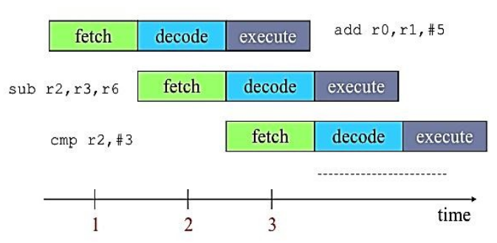
3. In first cycle add instruction fetch from memory
4. In second cycle add instruction is decoded and at the same time sub instruction is fetched from memory
5. In third cycle add instruction will execute , sub instruction will decode and new instruction i.e cmp will fetch from mamory.
6. In this way by using pipeline we can execute multiple instruction in single cycle.

5. Explain Linux boot sequence in case of ARM architecture?
Ans: Following are the steps for Linux booting sequence in case of ARM architecture:
1. Initiall switch on the power
2. BIOS
It stands for Basic input output system
Performs some system integrity checks
Searches, loads, and executes the boot loader program.
It looks for boot loader in floppy, cd-rom, or hard drive. You can press a key (typically F12 of F2, but it depends on your system) during the BIOS startup to change the boot sequence.
Once the boot loader program is detected and loaded into the memory, BIOS gives the control to it.
So, in simple terms BIOS loads and executes the MBR boot loader.
In this step basic hardware initialization takes place.
Location and execution will be at ROM only.
3. MBR
It stands for Master Boot Record
It is located in the 1st sector of the bootable disk. Typically /dev/hda, or /dev/sda
It contains information about GRUB (or LILO in old systems).
So, in simple terms MBR loads and executes the GRUB boot loader.
4. GRUB
GRUB stands for Grand Unified Bootloader.
If you have multiple kernel images installed on your system, you can choose which one to be executed.
GRUB displays a splash screen, waits for few seconds, if you don’t enter anything, it loads the default kernel image as specified in the grub configuration file.
So, in simple terms GRUB just loads and executes Kernel and initrd images.
5. Kernel
Mounts the root file system as specified in the “root=” in grub.conf
Kernel executes the /sbin/init programKernel executes the /sbin/init program
Since init was the 1st program to be executed by Linux Kernel, it has the process id (PID) of 1.
Initrd stands for Initial RAM Disk.
Initrd is used by kernel as temporary root file system until kernel is booted and the real root file system is mounted. It also contains necessary drivers compiled inside, which helps it to access the hard drive partitions, and other hardware
Mount root file system.
6. Init
Looks at the /etc/inittab file to decide the Linux run level
Following are the available run levels
- 0 – halt
- 1 – Single user mode
- 2 – Multiuser, without NFS
- 3 – Full multiuser mode
- 4 – unused
- 5 – X11
- 6 – reboot
Init identifies the default initlevel from /etc/inittab and uses that to load all appropriate program.
Typically you would set the default run level to either 3 or 5.
7. Runlevel programs
When the Linux system is booting up, you might see various services getting started. For example, it might say “starting sendmail …. OK”. Those are the runlevel programs, executed from the run level directory as defined by your run level.
Under the /etc/rc.d/rc*.d/ directories, you would see programs that start with S and K.
Programs starts with S are used during startup. S for startup.
Programs starts with K are used during shutdown. K for kill.
There are numbers right next to S and K in the program names. Those are the sequence number in which the programs should be started or killed.

